# Understanding SharePoint Workflows

Workflow is sometimes described as a series of tasks that produce an outcome. In the context of Microsoft SharePoint Products and Technologies, workflow is defined more narrowly as the automated movement of documents or items through a sequence of actions or tasks that are related to a business process. Workflows can be used to consistently manage common business processes within an organization by enabling the organization to attach business logic to documents or items in a SharePoint list or library. Business logic is basically a set of instructions that specifies and controls the actions that happen to a document or item.

Workflows can streamline the cost and time required to coordinate common business processes, such as project approval or document review, by managing and tracking the human tasks involved with these processes. For example, in an Office SharePoint Server 2007 site, you can add a workflow to a document library that routes a document to a group of people for approval. When the document author starts this workflow on a document in that library, the workflow creates document approval tasks, assigns these tasks to the workflow participants, and then sends e-mail alerts to the participants with task instructions and a link to the document to be approved. While the workflow is in progress, the workflow owner (in this case, the document author) or the workflow participants can check the Workflow Status page to see which participants have completed their workflow tasks. When the workflow participants complete their workflow tasks, the workflow ends, and the workflow owner is automatically notified that the workflow has completed.

The actions in the Approval workflow in this example follow the process shown in the following illustration.

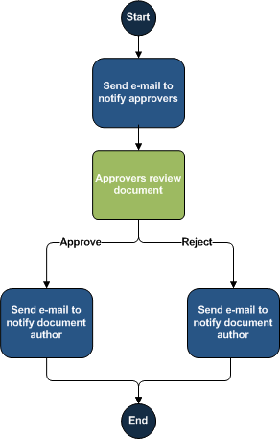

Workflows not only support existing human work processes but also extend the ways in which people can collaborate and work with documents, lists, and libraries. Site users can start and participate in workflows by using customizable forms that are accessible from the document or item in a SharePoint list or library. Additionally, the workflow functionality in Office SharePoint Server 2007 is tightly integrated with the 2007 Microsoft Office system. The following workflow tasks can be performed either in an Office SharePoint Server 2007 site or directly within certain client programs that are part of the 2007 Office release:

* View the list of workflows that are available for a document or item.
* Start a workflow on a document or item.
* View, edit, or reassign a workflow task.
* Complete a workflow task.